|  |  |  |  |  |  |
| --- | --- | --- | --- | --- | --- |
| **Cations** | | | | **Anions** | **H-bond donor** |
| **Imidazolium** | **Tetraalkylammonium** | **Pyrrolidinium** | **Piperidinium** | Cl-/Br- ion | Glycerol |
| 1-Ethyl-3-methylimidazolium [EtMeIm+] | N,N,-diethyl-N-methyl-N-(2- methoxyethyl)ammonium [Et2MeMeON+] | N-methyl-N-propylpyrrolidinium cation [MePrPyrrol+] | N-methyl-N-propylpiperidinium [MePrPip+] | Tetrafluoroborate [BF4-] | Ethylene Glycol |
| 1-Butyl-3-methylimidazolium [BuMeIm+] | Trimethylhexylammonium [Me3HexN+] | N-N-butyl-N-ethylpyrrolidinium [BuEtPyrrol+] | N-butyl-N-methylpiperidinium [BuMePip+] | Hexafluorophosphate [PF6-] |  |
| 1,2-Dimethyl-3-propylimidazolium [Me2PrIm+] | N-cyanomethyl-N,N,N-trimethylammonium [CMMe3N+] | N-N-butyl-N-methylpyrrolidinium [BuMePyrrol+] |  | Bis(fluorosulfonyl)imide [Nf2-] |  |
| 1,2-Diethyl-3,4-dimethylimidazolium [Et2Me2Im+] | N-cyanoethyl-N,N,N-trimethylammonium cation [CEMe3N+] | **Pyridinium** | **Other** | Bis(perfluoroethylsulfonyl)imide [NPf2-] |  |
| 1-Methyl-3-alkylimidazolium [MeRIm+] | Trimethylpropylammonium [Me3 PrN+] | N-butyl-4-methylpyridinium [BuMePy+] | Choline [Ch+] | Bis(trifluoromethanesulfonyl)imide [NTf2-] |  |
| 1,2-Dimethyl-3-butylimidazolium [BuMe2Im+] | N-methyl-N,N-diethyl-N- (methoxyethylene)ammonim [MeEt2MetoxyEtN+] | N-methyl-N-propylpyridinium [MePrPy+] | N,N-diethylenethanol ammonium | Triflate[OTf] |  |
| 1-Cyanomethyl-3-methylimidazolium [CMMeIm+] |  | N-butylpyridinium [BuPy+] | Methyltriphenylphosphonium | Tetrachloroaluminate [AlCl4-] |  |
| 1-Cyanopropyl-3-methylimidazolium [CPMeIm+] |  |  |  | 2,2,2-Trifluoro-N-(trifluoromethylsulfonyl)acetamide [TSAC] |  |

|  |  |  |
| --- | --- | --- |
|  | **Molecule class** | **Candidates** |
| **Cations** | **Imidazolium (8)** | 1-Ethyl-3-methylimidazolium [EtMeIm+], 1-Butyl-3-methylimidazolium [BuMeIm+], 1,2-Dimethyl-3-propylimidazolium [Me2PrIm+], 1,2-Diethyl-3,4-dimethylimidazolium [Et2Me2Im+], 1-Methyl-3-alkylimidazolium [MeRIm+], 1,2-Dimethyl-3-butylimidazolium [BuMe2Im+], 1-Cyanomethyl-3-methylimidazolium [CMMeIm+], 1-Cyanopropyl-3-methylimidazolium [CPMeIm+] |
| **Tetraalkylammonium (6)** | N,N,-diethyl-N-methyl-N-(2- methoxyethyl)ammonium [Et2MeMeON+], Trimethylhexylammonium [Me3HexN+], N-cyanomethyl-N,N,N-trimethylammonium [CMMe3N+], N-cyanoethyl-N,N,N-trimethylammonium cation [CEMe3N+], Trimethylpropylammonium [Me3 PrN+], N-methyl-N,N-diethyl-N- (methoxyethylene)ammonim [MeEt2MetoxyEtN+] |
| **Pyrrolidinium (3)** | N-methyl-N-propylpyrrolidinium cation [MePrPyrrol+], N-N-butyl-N-ethylpyrrolidinium [BuEtPyrrol+], N-N-butyl-N-methylpyrrolidinium [BuMePyrrol+] |
| **Piperidinium (3)** | N-methyl-N-propylpyrrolidinium cation [MePrPyrrol+], N-N-butyl-N-ethylpyrrolidinium [BuEtPyrrol+], N-N-butyl-N-methylpyrrolidinium [BuMePyrrol+] |
| **Other (3)** | Choline [Ch+], N,N-diethylenethanol ammonium, Methyltriphenylphosphonium |
|  | **Anions** | Cl-,Br-, Tetrafluoroborate [BF4-], Hexafluorophosphate [PF6-], Bis(fluorosulfonyl)imide [Nf2-], Bis(perfluoroethylsulfonyl)imide [NPf2-], Bis(trifluoromethanesulfonyl)imide [NTf2-], Triflate[OTf], Tetrachloroaluminate [AlCl4-], 2,2,2-Trifluoro-N-(trifluoromethylsulfonyl)acetamide [TSAC] |
| **H-B donor** | Ethylene Glycol |

10.1149/2.0061605jes

0.1016/j.rser.2013.10.004

10.1038/nmat2448

0.1016/j.jpowsour.2009.06.089

**Put DOI here**

**Imidazolium cations (RRIm+)**

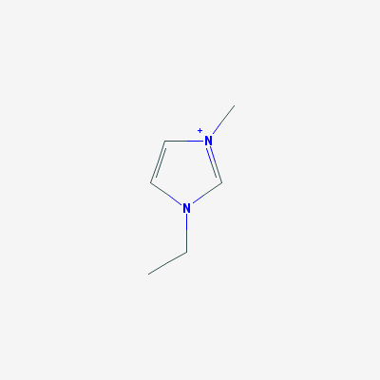 [EtMeIm+] 1-Ethyl-3-methylimidazolium cation

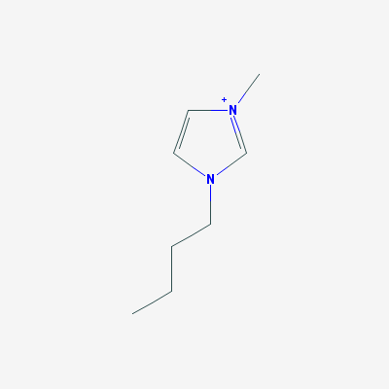 [BuMeIm+] 1-Butyl-3-methylimidazolium cation

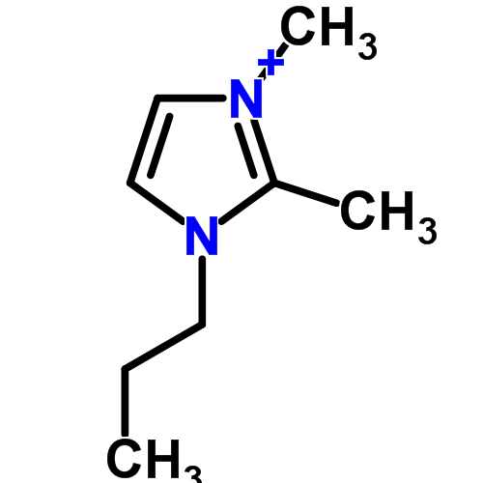 [Me2PrIm+] 1,2-Dimethyl-3-propylimidazolium

 [Et2Me2Im+] 1,2-Diethyl-3,4-dimethylimidazolium cation

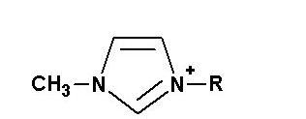 [MeRIm+] 1-Methyl-3-alkylimidazolium cation

 [BuMe2Im+] 1,2-Dimethyl-3-butylimidazolium cation

 [CMMeIm+] 1-Cyanomethyl-3-methylimidazolium cation

 [CPMeIm+] 1-Cyanopropyl-3-methylimidazolium cation

**Pyridinium cations (RRPy+)**

 [BuMePy+] N-butyl-4-methylpyridinium cation

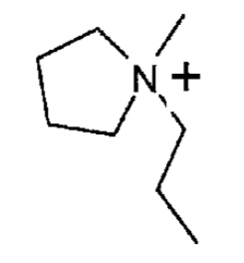 [MePrPy+] N-methyl-N-propylpyridinium cation

 [BuPy+] N-butylpyridinium cation

**Tetraalkylammonium cations (RRRRN+)**

 [Et2MeMeON+] N,N,-diethyl-N-methyl-N-(2- methoxyethyl)ammonium cation

 [Me3HexN+] Trimethylhexylammonium cation

[CMMe3N+] N-cyanomethyl-N,N,N-trimethylammonium cation

[CEMe3N+] N-cyanoethyl-N,N,N-trimethylammonium cation

 [Me3PrN+] Trimethylpropylammonium cation

[MeEt2MetoxyEtN+] N-methyl-N,N-diethyl-N- (methoxyethylene)ammonim cation

[Am4N+] Tetraamylammonium cation

**Pyrrazolium cations (RRRPyrraz+)**

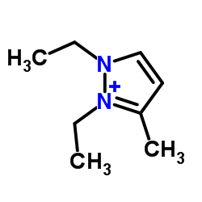[Et2MePyrraz+] N,N,-diethyl-3-methylpyrazolium cation

**Pyrrolidinium cations (RRPyrrol+)**

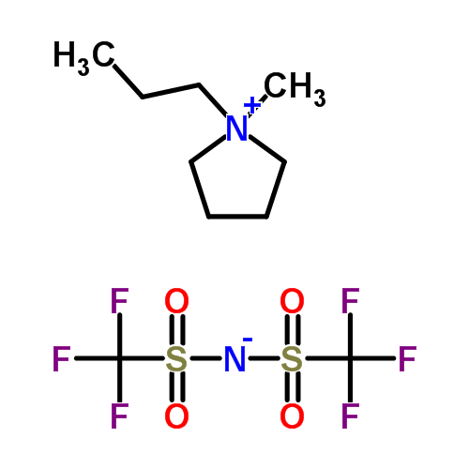[MePrPyrrol+] N-methyl-N-propylpyrrolidinium cation

[BuEtPyrrol+] N-n-butyl-N-ethylpyrrolidinium cation

 [BuMePyrrol+] N-n-butyl-N-methylpyrrolidinium cation

**Piperidinium cations (RRPip+)**

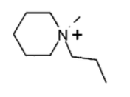[MePrPip+] N-methyl-N-propylpiperidinium cation

[BuMePip+] N-butyl-N-methylpiperidinium cation

**Anions**

 [BF4−] Tetrafluoroborate anion

 [PF6−] Hexafluorophosphate anion

 [Nf2−]; [N(F2SO2)2−] Bis(fluorosulfonyl)imide anion/ Bistriflimide/TFSI

 [NTf2−]; [N(CF3SO2)2−] Bis(trifluoromethanesulfonyl)imide anion

 [NPf2−]; [N(C2F5SO2)2−] Bis(perfluoroethylsulfonyl)imide anion

 [OTf−]; [CF3SO3−] Triflate anion

 [AlCl4−] Tetrachloroaluminate anion

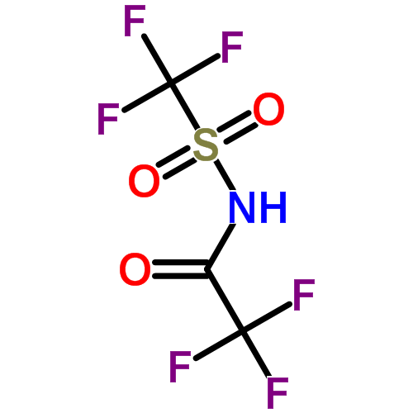 [TSAC−] 2,2,2-Trifluoro-N-(trifluoromethylsulfonyl)acetamide